How many more Runs will Root get?

What makes someone the greatest test batsmen – is it the number of test runs scored, or is it the average at which they do it, or is it the longetivity? Look at any of these parameters and Sachin Tendulkar is well and truly above the rest. A career that that spanned 24 years, 200 tests and 15956 test runs at an average of 50 has him one of the greatest test player. Then there are the likes of Ricky Pointing, Kallis, Dravid who’ve all played the game for years and amassed a lot of runs at a healthy average. None of these greats though have been in the conversation where we’d talk about if they could get ahead of total test runs scored by Tendularkar, until now. Since 2012, after Joe Roots, debut against in India he’s been slowly accumulating test runs at a steady pace and for the past five years at an alarming rate. And now suddenly this Yorkshiremen has sparked a questions, a conversation starter – Will he get close and surpass Tedulkar’s total ?

(Sachins career stats here - runs by year) – visualization

Root without a doubt is one of the finest test batsmen England has produced and Infact he might be one of the last breed of test-specialist batsmen with test cricket slowly “fading” away. With the future of Test cricket often being a major talking point, we are also potentially looking at the only real chance any test batter has to get close to Tendulkar’s run record. And we often times get stuck into a rut of comparing players against one another – the past and future. And while that can take away from the celebrating the players themselves, this is a unique opportunity something we might not be able to witness in Test cricket again.

Root currently sits in the second position at 13543 test runs, having over taken both Pointing and Kallis in the most recent Anderson-Tendulkar Trophy. In it he scored 537 runs at an average of 67.12 and added two more centuries to his burgenoing 100’s tally.

Even right now, as the interest in this conversation have peaked Root actually sits 2422 test runs away and slowly running out of time and tests.

While the cricket fan in me hopes and wishes that there will be many more opportunities, we know this is a rare moment.

If we were to extrapolate the number of innings Root needs to get to Tendulkars’ total runs looking at his career average :

Joe Roots career average = 51.29 (as of October 30th, 2025)
Tendulkar’s total test runs : 15956

Runs required to get past Tendulkar = 15957 – 13535 = 2422 runs
Total test required = 2422/ 51.29 = 48 test innings = Around 24 tests

This however, is a simple abstraction dependent solely on his career average which fluctuates season by season. To dig deeper let us look at England’s fixture over the next 24 tests, and see if the scheduling and his averages against these teams give a better insight on answering the question at hand.

Currently, we have scheduled fixtures for England starting from December 2025 – the Ashes to December 2026 for 11 tests. During this time, they play Australia away , and two home series against New Zealand and Pakistan.

Sn. | Date | Tournament | Venue | Stadium
1 | Nov 21,2025 | England in Australia | Perth | Optus Stadium
2 | Dec 4, 2025 | England in Australia | Brisbane | Brisbane Cricket Ground
3 | Dec 17, 2025 | England in Australia | Adelaide | Adelaide Oval
4 | Dec 26, 2025 | England in Australia | Melbourne | Melbourne Cricket Ground
5 | Jan 4, 2026 | England in Australia | Sydney | Sydney Cricket Ground
6 | June 4, 2026 | New Zealand in England | Lord's | Lord's Cricket Ground
7 | June 17,2026 | New Zealand in England | The Oval | The Kia Oval
8 | June 25, 2026 | New Zealand in England | Nottingham | Trent Bridge
9 | Aug 19, 2026 | Pakistan in England | Leeds | Headingley
10 | Aug 27, 2026 | Pakistan in England | Lord's | Lord's Cricket Ground
11 | Sep 9, 2026 | Pakistan in England | Birmingham | Edgbaston

Root career can also be divided into two halves – one before 2021 (under 30) and one since 2021 (after turning 30) . In the first half, before 30 Root average 47.72 from 97 tests with 17 centuries and twice has average below 40.

In the second half (Since 2021) Root has scored at an average of 56.63 from 61 tests and has scored 22 centuries.

Root clearly has been going strength to strength after turning 30 which is also one the main reason we are even having this conversation.

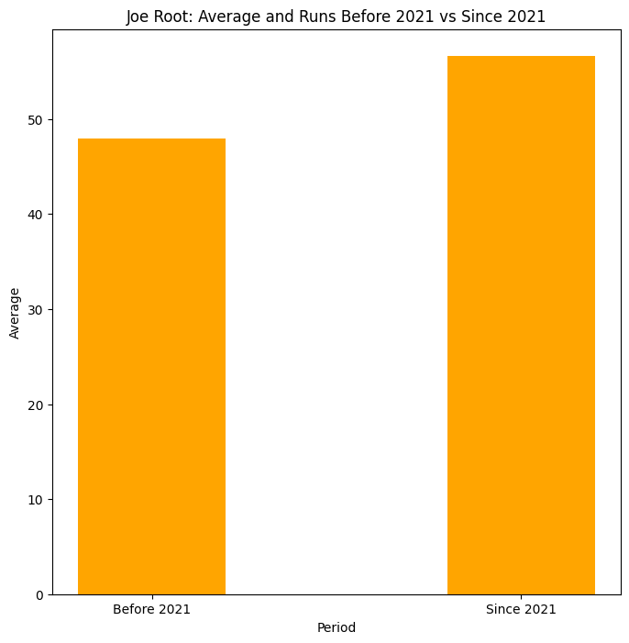
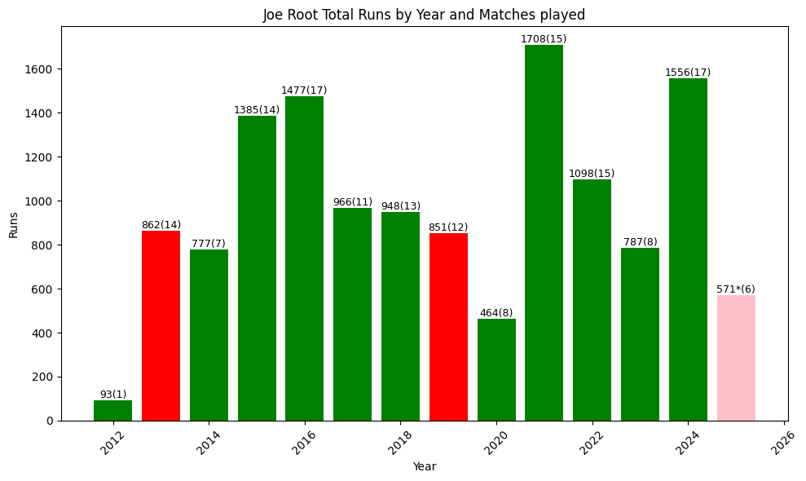

Centuries graph (can go here)

If we look at the two scenarios then, what happens if Root scores at an average before 30
And after 30.

2012-2020 (Before turning 30)

Total test required = 2422 / 47.72 = around 51 innings = Around 26 tests

2021-2025* (After 30)

Total test required = 2422 / 56.63 = around 43 innings = 22 tests

11 of those test he will play in 2025/26. Another 11 test in 26/27 (source) and we can expect Root to get to the magical number end of 2027 or early 2028 by which time he will be 37.

Where will Root end up at the end of the 2026 ?

The fixtures till the end of the 2026 have been decided, and barring any injuries and other unfortunate incidents, Root will likely play the 11 tests until the end of 2026 against Australia (away), and at home to Newzealand and Pakistan.

First up there is the Ashes and again unless Root is protected like he was back when he had just come into the team (source) we can expect Root to play all the five tests.

Root travels to Australia for an Ashes in the twilight of his career and under a bit of pressure of having never scored a hundred here. But for all the talk about him not having a hundred here, he still averages a healthy 40.46 against the Australians overall, and 35.68 in 14 tests in Australia.

Career average by opposition

By the end of 2026, Root will have played tests series against Australia, New Zealand, and Pakistan. If he were to score runs as per his career averages against these sides,

 | Career Avg | Expected runs | Total Runs (13543*) | Difference from Tendulkar
Vs Australia (A) | 40.46 | 404 (10 innings) | 13947 | 1974
Vs New Zealand (H) | 53.47 | 321 (6 innings) | 14268 | 1653
Vs Pakistan (H) | 53.10 | 319 (6 innings) | 14587 | 1334
 |  | 1044 runs

At the end of the 2026 calendar year, Root will have another 1044 runs and will be 1334 runs away from Tendulkar’s total.

Career average by Host nation venue

The overall averages though misses the point that Root has scored his runs differently at home and away. If he were to score his as per his country specific average then -

 | Career Avg | Expected runs | Total Runs (13543*) | Difference from Tendulkar
Vs Australia (A) | 39.66 | 396 (10 innings) | 13939 | 1982
Vs New Zealand (H) | 57.43 | 344 (6 innings) | 14283 | 1638
Vs Pakistan (H) | 55.61 | 333 (6 innings) | 14616 | 1305
 |  | 1073 runs

While Root averages less than 40 in Australia and less than his career average against Australia, he does average higher against both New Zealand and Pakistan at home. And he will be 29 runs to Tendulkars runs at the end of 2026 if he were to score at the average he usually does against these sides.

With 11 tests to follow up in 2027, by the end of which time Root will be 37, leaves him a bit over 1000 runs to get. And by the time, if he is still averaging his career average of 51.29 then,

51.29 x 22 innings = 1128 runs

Total runs = 15744
Difference = 176 runs

The difference between the two will still be 176 runs.

If Root and Tendulkar were playing their own individual sport of cricket, where Root was chasing Tendulkar’, it is fair to say this one is heading towards a nail biting finish.

In the end though, the question is will Root hang around to break the 16000 test runs landmark. Root is 35 years old now, and in two years he will be 37 and given how fit he is, he will be around physically, but will he still have the hunger to bat. I think we should have a better picture of this in the given days to come. But right now, Root is well and truly on his way to 16000. And whether he gets there or not, he is a generational batter.

Useful Urls :
https://stats.espncricinfo.com/ci/engine/player/303669.html?class=1;template=results;type=allround

December 30, 1990, Sheffield, Yorkshire
Age
34y 305d
Debut : 12 December at 21 years old

